# Raster!

## The ‘Other’ GIS Data.

Stacey Maples – Geospatial Manager – Stanford Geospatial Center – [stacemaples@stanford.edu](mailto:stacemaples@stanford.edu)

David Medeiros – GIS Instruction & Reference Specialist - Stanford Geospatial Center - [davidmed@stanford.edu](mailto:davidmed@stanford.edu)

The Raster Data Model provides an effective means of characterizing spatially continuous phenomena, such as elevation, temperature, precipitation and other environmental and climatic characteristics. This workshop provides a targeted introduction to the tools available in ArcGIS for creating, managing and analyzing data in raster form. Topics will include:

* Types of Raster Data
* Properties of Raster Data
* Symbolization & Display of Raster Data
* Imagery Analysis in ArcGIS
* The Spatial Analyst Toolset
* Extracting Data from Raster to Vector
* Map Algebra and Raster

## GIS Resources:

Stanford Geospatial Center website - <http://gis.stanford.edu/>

Stanford GIS Listserv - <https://mailman.stanford.edu/mailman/listinfo/stanfordgis>

Esri ArcGIS 10.2 Help - <http://resources.arcgis.com/en/help/main/10.2/>

## Download Tutorial Data

1. In a browser, go to <https://stanford.box.com/SGCIntroGIS> and click on the drop-down arrow to the right of each folder to download individual datasets. Save the Dataset to your Desktop.
2. Right-click on the resulting **\*.zip** file and select Extract All…
3. Accept all defaults to extract the data file.

## The Image Analyst Toolbar

1. **Browse** to the **\Raster\EX_05_Raster folder** and **double-click** on the **Raster.mxd** document to **open** it.

### Setting Options

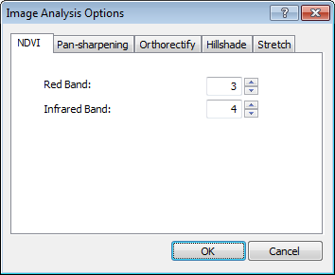There are a number of **Options Settings** you want to pre-populate with values appropriate for your particular project/data.

1. On the **Main Menu**, **go to** **Windows>Image Analysis.**
2. **Click** on the **Options Button**, at the top left corner of the **Image Analysis Window**.

#### NDVI

This setting tells the **Image Analysis Window** what Bands from the **_NAIP_4_Color_Band_Orthophotography1** should be used for the Infrared and Red Spectral Samples when calculating NDVI (Normalized Difference Vegetation Index).

1. **Click** on the **NDVI Tab**, if it is not already at the front of the **Options Window**.
2. 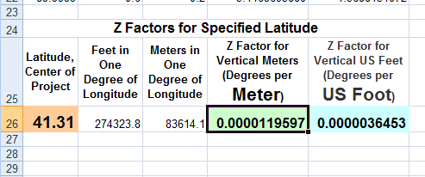**Set Red Band to 3 and IR Band to 4.**

#### Z-Factor

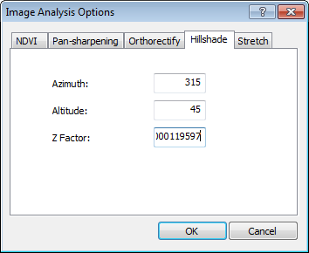This setting is essentially a corrective value. The NED Elevation data in this project is in Geographic Coordinate System NAD1983. This means that the pixel dimensions are expressed in Degrees of Longitude, rather than linear units. The z-factor is the amount of correction needed to make to operations that depend upon Rise and Run calculations, to correct for this, since these operations assume the unit of pixel dimension in the dataset is the same as the elevation values. The value is sensistive to the Lattitude of the dataset, since as Latitude increases or decreases from the Equator, lines of Longitude converge to a point, and the linear width of a degree of Longitude, decreases.

1. **Browse** to **Raster Folder** and **open** the **Z_Factor.xls** file in Excel
2. Note that the Latitude Center of Project Value has already been set to 41.31, which is appropriate for this project.
3. **Right-click** on the value for the **Z Factor for Vertical Meters**
4. **Return** to **ArcMap** and **Click** on the **Hillshade Tab**.
5. 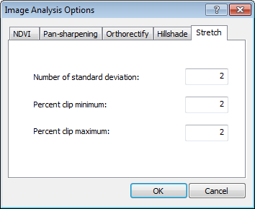**Right-click** and **Paste** to **Set** the **Z Factor** to **0.0000119597**

#### Stretch

The Stretch Setting controls how much of the data in a raster image is used to render that dataset. In general, a certain amount of data from the top and bottom of the image values histogram is excluded in order to create a more vivid visualization.

1. **Click** on the **Stretch Tab** and sett all of the **Stretch Settings** to **2**.
2. **Click OK**.

### Using the Image Analysis Tools

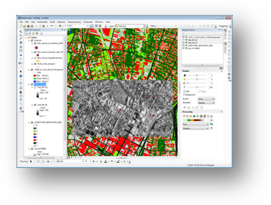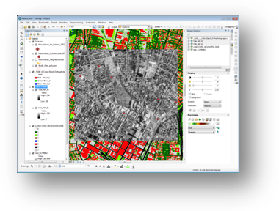

#### Mosaic

**Mosaicking** is the process of taking two or more raster datasets of similar data and combining them into a single dataset.

1. In the **Table of Contents**, **right-click** on the **Ortho Photos Group Layer** and **Zoom to Layer**.
2. **Toggle** the **Visibility** of the **Yale_NH_02 layer** to see that this image is actually two separate image rasters.
3. 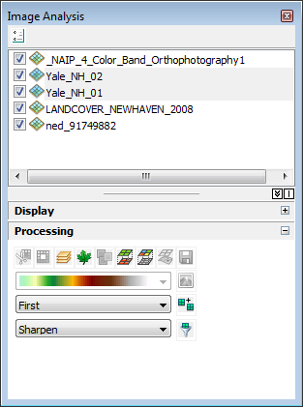In the **Image Analysis Window**, **click** on the two **Yale_NH_01 & _02 Layers** while **holding down the Ctrl key** to select them.
4. Under the Processing Section, change the Mosaic Method to First.
5. **Click** on the **Mosaic Button**C:\Users\sdm53\Pictures\ScreenCaps\Raster\mosaic button.png.
6. Note that a new raster layer is added to the Table of Contents, as well as the Image Analysis layer list. This is the newly mosaicked ortho image.
7. **Turn off the visibility** of the original **Yale_NH_01 &_02 layers** and note that the new Mosaic_Yale_NH_02 Layer is the combination of these two layers.

#### C:\Users\sdm53\Pictures\ScreenCaps\Raster\clip draw polygon.pngClip

This function allows you to “clip” the raster dataset of interest to a particular extent.

1. **Zoom** into the area around the **Yale Hockey Arena** (as shown on the right).
2. Use the **Draw Rectangle ToolC:\Users\sdm53\Pictures\ScreenCaps\Raster\Draw rectangle tool.png**, from the **Drawing Toolbar**, to **draw a square** around the Yale Hockey Arena approximately 1 city block square.
3. In the **Image Analysis Window**, **Select** the **Mosaic_Yale_NH_02 Layer**.
4. 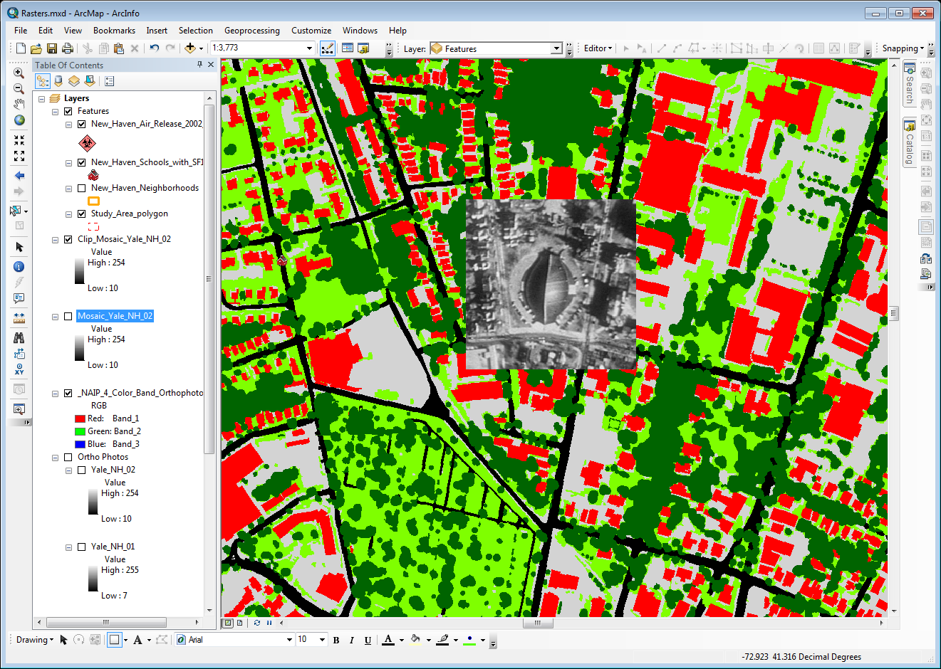**Click** on the **Clip Button C:\Users\sdm53\Pictures\ScreenCaps\Raster\clip buttin.png** to create the **Clip_Mosiac_Yale_NH_02 Layer**.
5. **Uncheck** the original **Mosaic_Yale_NH_02 layer** **to turn off its visibility**
6. **Right click** on the **square** that you drew in the Data Frame and **Delete it**.

Note that the Image has been clipped to the rectangle you created. This Clip Function can be used to clip to current Data Frame extent but selecting the Data Frame name at the Top of the Table of Contents, rather than using a drawing object.

#### C:\Users\sdm53\Pictures\ScreenCaps\Raster\image properties functions.pngImage Layer Files and Functions

When the results of each of the operations we have run are added to the map, there is no new data being created. What is happening is that the output of each of the functions in the Image Analysis toolbar is actually an “Image Layer” that (like the vector layers we are used to working with in the Table of Contents) contains a reference link to the source imagery and “instructions” about how to visualize the imagery. Successive operations are added to the layer and can be removed at any time.

#### Remove Clipping Function

1. **Remove** the **original Yale_NH_01 & _02 layers**, as well as the **Mosaic_Yale_NH_02 Layer**.
2. **Right-click** on the remaining **Clip_Mosaic_Yale_NH_02 layer** and **open** its **Properties**.
3. **Right-click** on the **Clip Function** item and **remove** it. **Click OK**.

Note that the clipped extent has now reverted to the original full extent of this layer. Again, no new imagery data has been created, only the instructions for displaying the imagery have changed. If you want to create a new raster layer based upon your Image Analysis functions, it is necessary to export the data to a new raster.

#### Exporting an Image Layer to Raster Data

1. 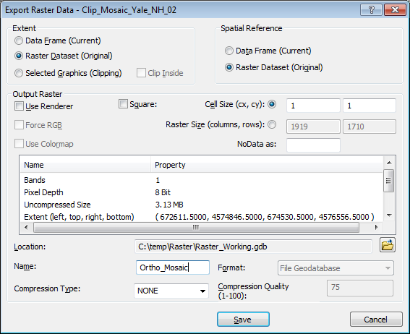**Click** on the **Clip_Mosiac_Yale_NH_02 Layer** in the **Image Analysis Window** to select it.
2. **Click** on the **Export Button** C:\Users\sdm53\Pictures\ScreenCaps\Raster\Image Analyst Export.png.
3. Leave the **Default Settings** for **Extent, Spatial Reference and Output Raster**.
4. Browse to and select the **Raster_Working.gdb** as the **Location**.
5. **Name** the **Output Raster** **Ortho_Mosaic** and **click Save**.
6. **Click** **Yes** when prompted to **add** the **exported data** to the Map.
7. **Right-click** the original **Clip_Mosaic_Yale_NH_02 Layer** and **remove** it.

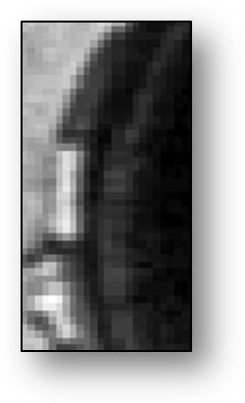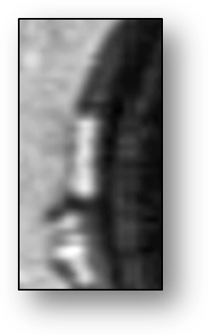

1. Use the **Catalog Window** to **view** the contents of the **Working_Raster.gdb** and **confirm** that the **new Ortho_Mosaic** dataset is there.

### Display of Raster Data

#### Stretch

“Stretching” the display of an image refers to the removal of a subset of values at the upper and lower end of the image value histogram in order to increase the display quality/contrast. Here, we will remove the upper and lower 2% of values (set by the Stretch Value you entered under the Settings Window at the beginning of the exercise).

1. **Zoom** into the **Yale Hockey Arena**, again.
2. **Click** on the **Ortho_Mosiac layer** in the Image Analysis Window to **select** it.
3. **Change** the **Stretch** dropdown value to **Percent Clip**

#### Resample

Resampling, in the context of image display, allows you to control the “smoothness” of an image as screen and print resolution move beyond the raster resolution. In this part of the exercise, we will change from Nearest Neighbor (no smoothing) to Cubic Convolution.

1. **Change** the **Resample Method Dropdown** to **Cubic Convolution**.
2. 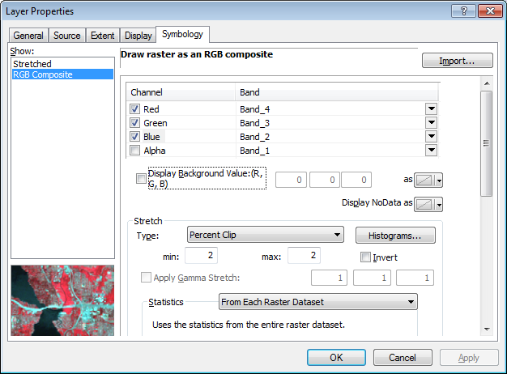Note the “softening of the image.

### Vegetation Indices

#### False Color Infrared Images

1. **Right-Click** and **Zoom to Layer** on the **_NAIP_4_Color_Band_Orthophotography1 layer**.
2. **Select** the **_NAIP_4_Color_Band_Orthophotography1** in the **Image Analysis Window** and **apply** a **Percent Clip** Stretch.

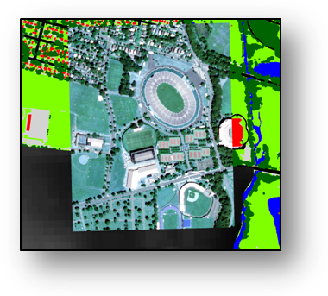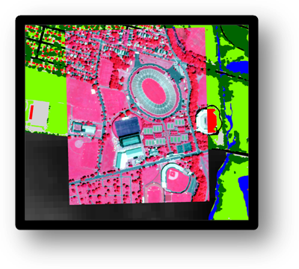

1. **Right-click** and **Copy** the **_NAIP_4_Color_Band_Orthophotography1 Layer.**
2. **Right-Click** on the “**Layers**” item at the top of the **Table of Contents** and **select Paste Layer(s).**
3. **Rename** the pasted layer “**432 False Color Infrared**”
4. **Drag** the **432 False Color Infrared layer** to just **above** the **_NAIP_4_Color_Band_Orthophotography1 Layer** in the **Table of Contents**.
5. **Right-Click** and **Open** the **Properties** of the **432 False Color Infrared layer**.
6. **Click** on the **Symbology Tab** and **set** the **Color to Band settings** as follows:  
   1. **Red = Band 4** (Infrared Spectral Sample)
   2. **Green = Band 3** (Red Visible Spectral Sample)
   3. **Blue = Band 2** (Green Visible Spectral Sample)
7. **Click OK** to apply the changes in symbology.
8. **Turn on** the **Effects Toolbar** and **make** the **432 False Color Infrared Layer the target**.
9. **Select** the **Swipe Tool**  and **click once** **at the top of the 432 False Color Infrared Image** in the Data Frame.
10. **Click and Hold**, then **swipe** from top to bottom to peel the 432 image off of the Original Natural Color layer.

What you have created is referred to as a 432 False Color Infrared Image. This use of a spectral band outside the visible part of the spectrum takes advantage of the fact that healthy vegetation reflects very highly in the infrared part of the spectrum. What you see in this image is healthy vegetation in areas where the deep reds and pinks are evident.

## Working with Digital Elevation Models (DEM) and Surfaces

### Z-Factor in Spatial Analyst Surface Geoprocessing Tools

Many of the Geoprocessing tools that operate on Digital Elevation Models (or raster datasets being treated as DEMs) depend upon Rise/Run calculations. These calculations assume that the Rise and Run (Elevation and Cell Size) are in the same units, which is not the case when dealing with DEM data that is in an unprojected Geographic Coordinate System. In this case, it is necessary to provide a value that can be used to correct the Rise values to match those of the Run. This value is the Z Factor, and it is dependent upon the Latitude of the center of your dataset. We previously set the Z-Factor in the Imagery Analysis Window Options, but the Z-Factor must also be set when using Surface Tools in ArcToolbox

### Characterizing Landscape

#### C:\Users\sdm53\Pictures\ScreenCaps\Raster\slope tool.pngSlope

1. **Right-click** and **Zoom** to the **ned_91749882 layer**.
2. **Search** for and **open** **the Slope Tool from Spatial Analyst.**
3. Set the **ned_91749882 layer** as the **Input raster**.
4. Shorten the default **Output raster name** to “**Slope**”
5. **Change** the **Output measurement** to **PERCENT_RISE**
6. **Set** the **Z Factor** to **0.0000119597** (return to the Z-Factor.xls file, if necessary) and **click OK** to run the tool.

#### Aspect

1. 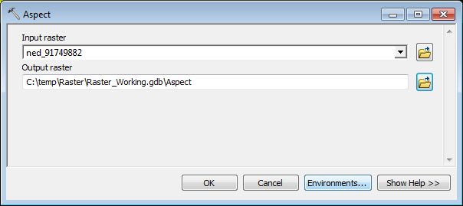**Search** for and **open** the **Aspect tool from Spatial Analyst**.
2. Set the **ned_91749882** **layer** as the Input raster.
3. Shorten the default **Output raster name** to “**Aspect**” and **click OK**

#### C:\Users\sdm53\Pictures\ScreenCaps\Raster\hillshade in Image Analysis.pngHillshade

1. Return to the **Image Analysis Window** and **click** on the **ned_91749882 layer** to **select** it.
2. **Select** a **Color Ramp** from the Dropdown in the **Processing Panel** of the **Imagery Analysis Window.**
3. **Click** on the **Hillshade Button**C:\Users\sdm53\Pictures\ScreenCaps\Raster\hillshade button.png.

## Map Algebra

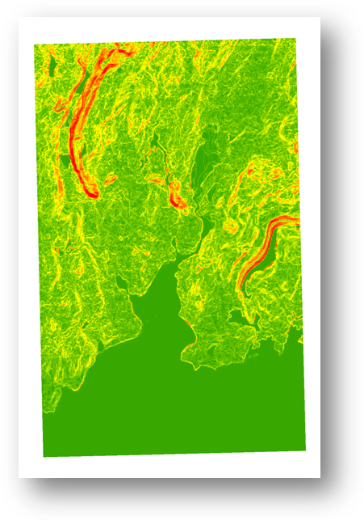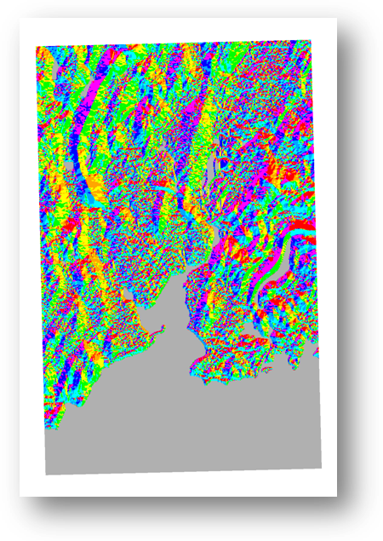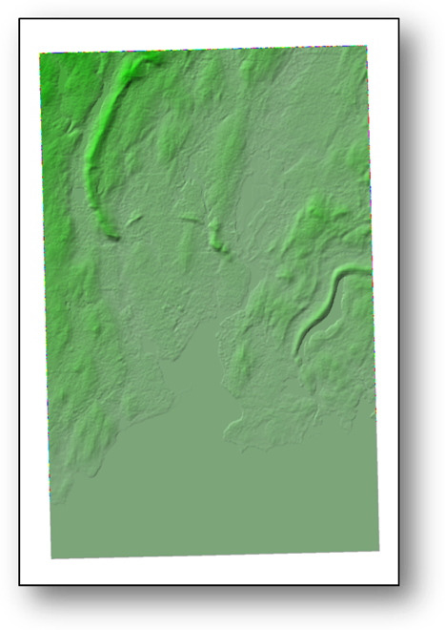

## **Hillshade**

## **Aspect**

## **Slope**

1. 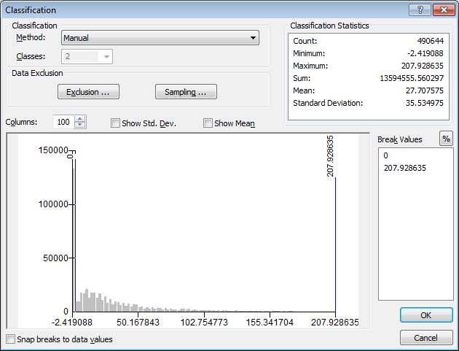On the **Main Menu**, go to **File>Add Data>Add Basemap**
2. **Select** the **OpenStreepMap Basemap**
3. **Turn off all layers** **but** the **OpenStreetMap basemap and the Study_Area_Polygon layer**.

#### Reclassify Tool

1. 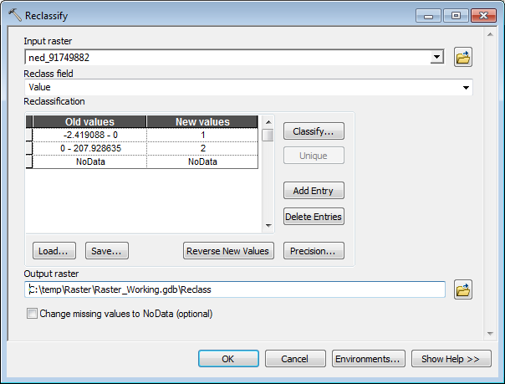**Search** for and **open** the **Reclassify tool**.
2. Set the **Input Raster Dataset** to **ned_91749882**.
3. **Click** on the **Classify Button** to launch the **Classify Window**.
4. **Change** the **Classification Method** to **Defined Interval**, and then **change** the **number of Classes to 2**.
5. 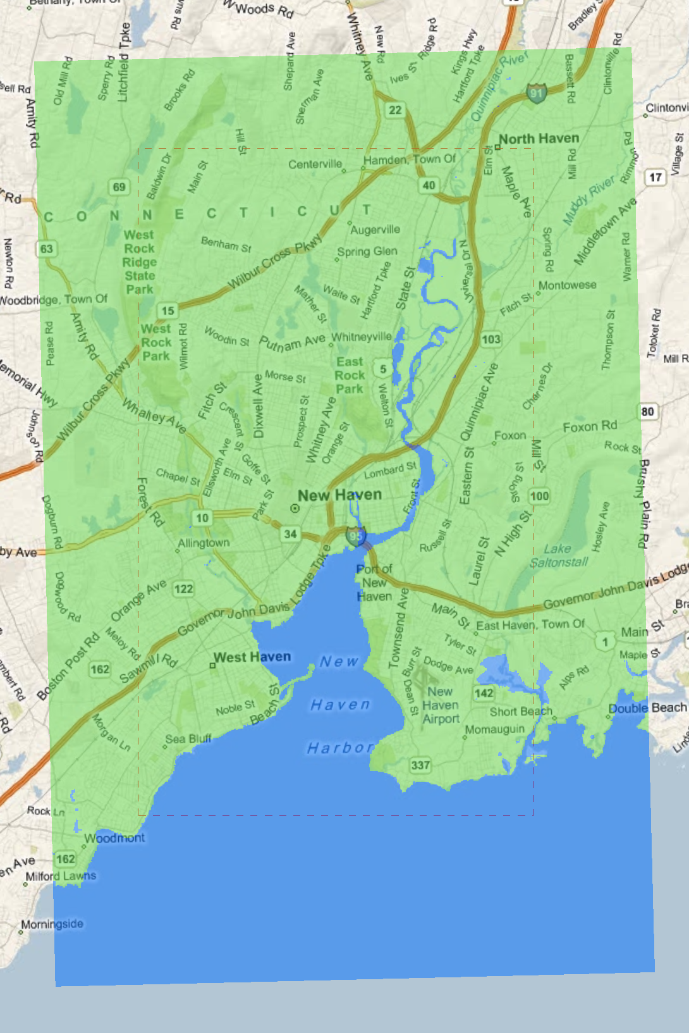**Change** the **Classification Method** back to **Manual**.
6. In the **Break Values Panel** on the right side of the window, **change the first Break Value to 0** and **click OK.**
7. Change the **name** of the **Output Raster** to “**Reclass**” and **click OK**.

##### Set Transparency

1. **Right Click** on the resulting **Reclass Raster** **Layer** and **open** its **properties**.
2. **Click** on the **Display Tab**
3. Set the **Transparency Value to 50%**
4. **Click OK**.
5. 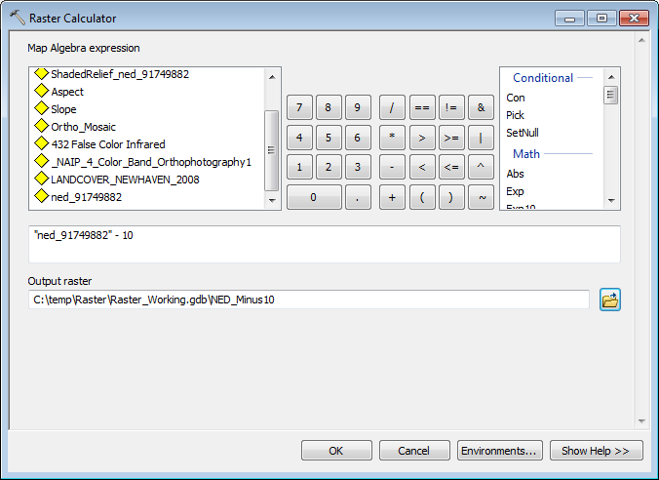**Right-click** on the **color patches** for the two classes to **change** to more appropriate colors.

#### Modeling Sea Level Change Using Raster Calculator

1. **Search** for and **open** the **Raster Calculator Tool.**
2. **Double-click** on the **ned_91749882 layer** to place it into the argument window.
3. 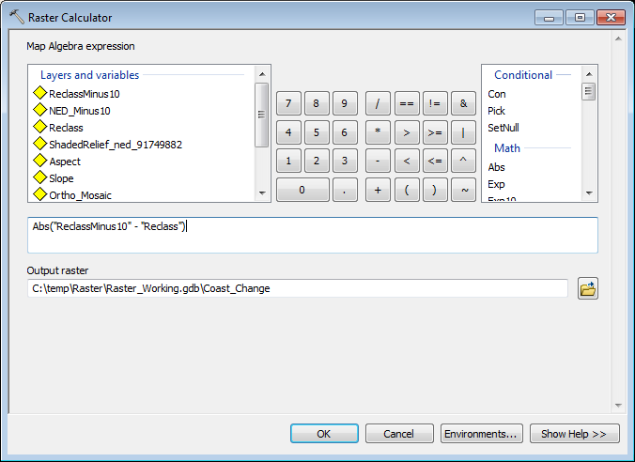**Finish the Map Algebra Expression with “-10”**so that it reads:  
     
   **“ned_91749882”-10**
4. **Name** the **Output Raster NED_Minus10** and place **it in the Raster_Working.gdb.**
5. **Click OK**

#### Reclass the NED_Minus10

1. 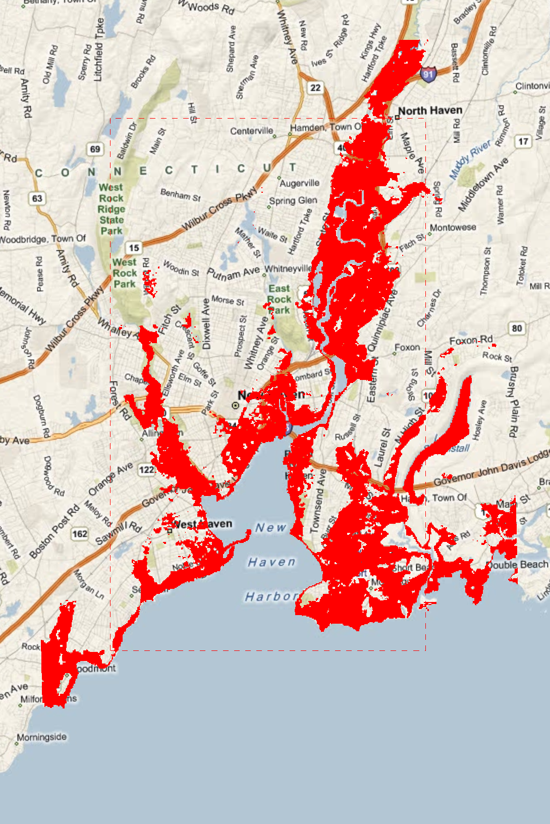**Repeat the steps you used to reclassify the original**, but use the **NED_Minus10 layer as the Input raster** and **name** the **Output Raster “ReclassMinus10”**

#### Change Detection

1. **Search** for and **open** the **Raster Calculator**, again.
2. **Subtract the original Reclass layer from the ReclassMinus10 layer** and output the **Absolute Value** using the following equation:  
     
   **Abs("ReclassMinus10" - "Reclass")**
3. **Name** the **Output Raster “Coast_Change”**
4. **Click OK** to apply the calculation.
5. **Right-click** on the **color patch** for the **0 value** in the resulting layer and **set** it to **“no color.”**
6. **Set** the **1 value to Red**
7. **Turn off the visibility** **of all but the Coast_Change layer** and the **Bing Maps Road Basemap** to observe the modeled coastal change.

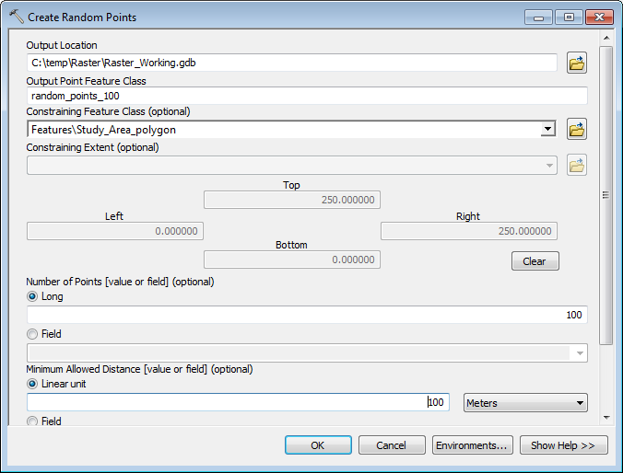

### Extracting Data

##### Create a Random Distribution of Point

1. **Turn off all layers but the Study_Area_Polygon layer, the ned_91749882 layer and the Bing Maps Road basemap.**
2. **Search** for and **open** the **Create Random Points tool**.
3. Set the **Output Location** to the **Raster_Working.gdb**.
4. **Name** the **Output Point Feature Class “random_points_100”**
5. **Select** the **Study_Area_polygon layer as the Constraining Feature Class.**
6. **Confirm** that the **Number of Points is set to 100.**
7. **Set** the **Minimum Allowed Distance to 100 meters**.
8. **Click OK** to create the Random Points Feature Class.

#### C:\Users\sdm53\Pictures\ScreenCaps\Raster\Extract multi values to points.pngExtract Multi Values to Points

1. **Search** for and open the **Extract Multi Values to Points tool.**
2. Set the **random_points_100** as the **Input Point Features**.
3. 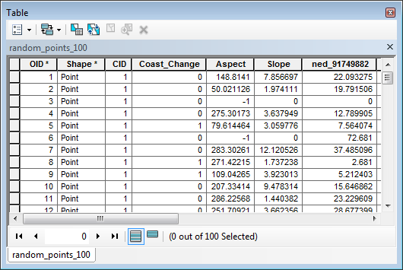**Add** the following as **input rasters:**
   1. **Coast_Change**
   2. **Aspect**
   3. **Slope**
   4. **ned_91749882**
4. **Click OK**.
5. When the Geoprocessing tool has finished running, **right-click and Open the Attribute table of the random_points_100 layer** and confirm that the values of the raster layers have been extracted to the attribute table.

#### C:\Users\sdm53\Pictures\ScreenCaps\Raster\Zonal Statistics as table.pngZonal Statistics as Table

1. **Search** for and **open** the **Zonal Statistics as Table Tool.**
2. Set the **New_Haven_Neighborhoods** **Layer** as the **Input Feature Zone Data.**
3. Select the **ned_91749882 layer** as the **Input Value Raster**
4. **Name** the **Output Table** “**Zonal_Stats**” and **save** it **to** the **Raster_Working.gdb**
5. **Confirm** that the **Statistics Type** is set to **ALL**.
6. 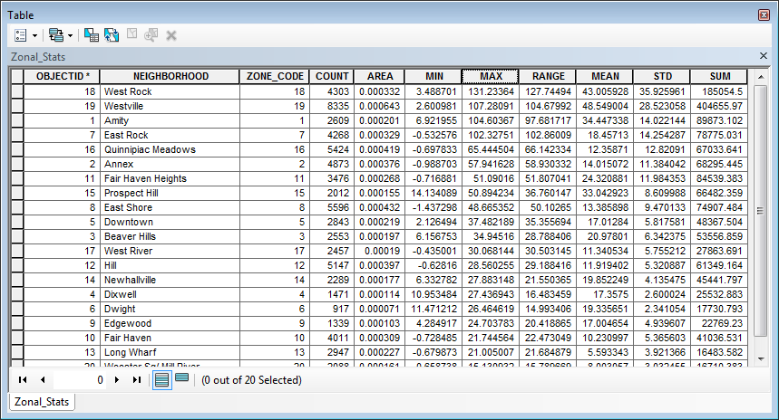**Click OK**
7. **Open** the resulting **Zonal_Stats Table** to review the statistical summary of the elevation variable for New Haven Neighborhoods.

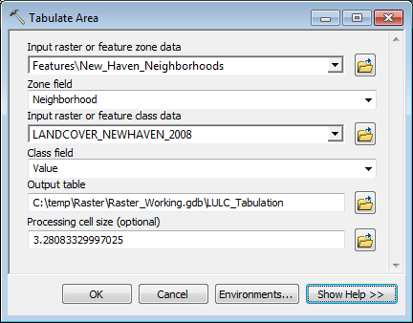

#### Summarizing Areas using Tabulate Areas- LULC

1. **Search** for and open the **Tabulate Area too**l from the **Spatial Analyst Tools.**
2. **Select** the **New_Haven_Neighborhoods Layer** as the **Input Feature Data**.
3. **Select** the ‘**Neighborhood’** **field** as the **Zone Field**.
4. 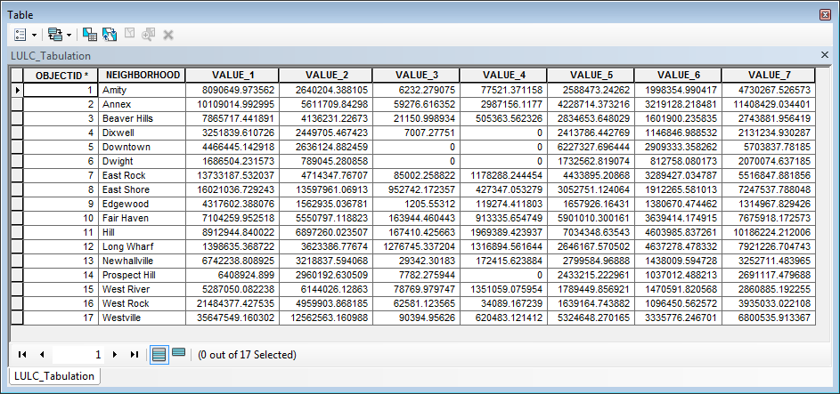**Select** the **LANDCOVER_NEWHAVEN_2008 layer** as the **Input Raster Data**.
5. **Select Value** as the **Class Field**.
6. **Name** the **Output Table LULC_Tabulate** and **save** it to the **Raster_Working.gdb**.
7. Leave the **default Processing Cell Size**
8. **Click OK.**
9. **Open** the **resulting LULC_Tabulate** table to see that you have produced a table that records the area (in square feet) for each Landuse Class, in each Neighborhood.